Come join our team!
*** PLEASE READ PRIOR TO COMPLETING THE APPLICATION***
PER UNITED STATES COAST GUARD REGULATIONS, CREW MEMBERS ONBOARD THE PRIDE OF AMERICA MUST BE UNITED STATED CITIZENS OR PERMANENT RESIDENTS RESIDENT ALIENS(GREEN CARD HOLDERS). FAILURE TO MEET THIS REQUIREMENT WILL AUTOMATICALLY DISQUALIFY YOU FOR EMPLOYEMENT CONSIDERATION ONBOARD THE PRIDE OF AMERICA.
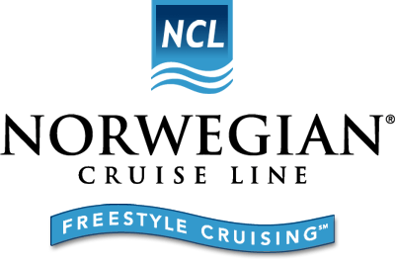
Join us at an upcoming private recruitment event to learn about embarking on a lifestyle changing career aboard the Pride of America.
Tuesday, August 30, 2016
Long Beach, CA
'Renaissance Hotel'
111 E. Ocean Boulevard
Long Beach, CA 90802
Session 1 @ 9 AM
Session 2 @ 2 PM
Candidates must complete an on-line application prior to attending the event. Candidates whose backgrounds match the requirements of current vacancies will get a private invitation to attend the event and meet with a Norwegian Cruise Line Holdings Recruiter.
During the private invitation only session, you will get to learn about shipboard employment. This will be immediately followed by a personal one on one interview.
Norwegian Cruise Line is currently looking for energetic, hospitality-minded professionals with both recent and relevant experience in one of the following categories:

- Bar Waiter
Assistant cook
- Assistant Waiter
- Laundry Personnel
- Restaurant Steward - Busser/Server
- Stateroom Steward - Hotel Room Housekeeping
- Utility - Janitorial in Galley & Hotel
- Photographer

IMPORTANT REQUIREMENT FOR ALL APPLICANTS:
You must have a GED or High School Diploma
- You must be legally authorized to work in the U.S. and qualify for a U.S. Coast Guard Merchant Mariner Credential (MMC) as well as a Transportation Workers Identification Credential (TWIC).
- In order to qualify for an MMC you must:
- Be at least 18 years of age
- Be a US Citizen or Permanent Resident Alien
- Pass Physical Exam/Drug Screen
- Have a Reasonably Clear Background

Please note:
- The doors will be closed and no entry once the presentation begins.
- It is only necessary to attend one presentation.
- Bring an Updated Resume, Smiling faces and Hospitality attitude!

